|  |  |  |  |
| --- | --- | --- | --- |
| **Group No.** | **Group Members** | | |
|  | **ID** | **Name** |
| **3** | 1. | 20-42794-1 | FAHIM, SHAH NAWAJ |
| 2. | 20-42752-1 | HOWLADER, MD. SHAKIB |
| 3. | 20-42195-1 | LEO, NAFINUR |
| 4. | 20-42870-1 | HASSAN, MD. ALIF |
| 5. | 20-42853-1 | RAHMAN, HASIBUR |
| 6. |  |  |

**Laboratory Experiment Report**

Electronic Devices Laboratory

Semester: Spring 2021-22

|  |  |  |
| --- | --- | --- |
| Experiment No.: 03 |  | |
| Experiment Title: Study of diode clipping and clamping circuit. |  | |
| Date of Experiment: 05-02-2022 | | Date of Report Submission: 16-03-3033 |

**Marking Rubrics for Laboratory Report (to be filled by Faculty)**

|  |  |  |  |  |
| --- | --- | --- | --- | --- |
| **Objectives** | **Unsatisfactory (1)** | **Good (2-3)** | **Excellent (4-5)** | **Marks** |
| **Theory** | The relevant theories are not being described properly. | Part of the relevant theories are described with proper mathematical expression and circuit diagrams (if any) | All the relevant theories are included with proper descriptions, mathematical expressions and circuit diagrams. (if any) |  |
| **Simulation circuits & Results** | Simulation circuits are not included in this report. | Partial simulation circuit results are included in this report. | All the simulation circuits are included in this report with appropriate results. |  |
| **Report Question, Discussion on Comparison between theoretical and simulation results** | Cannot reach meaningful conclusions from experimental data; Cannot summarize or compare findings to expected results | Can extract most of the accurate data. Answers to the report questions are partially correct; Summarize finding in an incomplete way | Can extract all relevant conclusion with appropriate answer to the report questions; Summarize finding in a complete & specific way |  |
| **Organization of the report** | Report is not prepared as per the instruction. | Report is organized despite of few missing sections as per the recommended structure. | Report is very well organized. |  |
| **Comments** | Assessed by (Name, Sign, and Date) | | Total (out of 20): |  |

**(1) Experiment title:** Study of Diode Clipping and Clamping Circuits.

**(2) Objective of this experiment:**

The objectives of the Experiment 3 of the Electronic Devices Lab are,

• To know about diode effects on circuit.

• Applying diode clipping and clamping circuit.

**(3) Relevant Theory:**

Clipper circuits clip off portions of signal voltages above or below certain limits, i.e. the circuits

limit the range of the output signal. The level at which the signal is clipped can be adjusted by

adding a dc bias voltage in series with the diode as shown in Fig. 1 of the circuit diagram part.

In a series positive clipper, a diode is connected in series with the output, as shown in Fig 1(a).

During the positive half of the input voltage, the terminal A is positive with respect to B. These

reverse biases the diode and it acts as an open switch. Therefore, all the applied voltage drops

across the diode and none across the resistor. As a result of this there is no output voltage

during the positive half cycle of the input voltage.

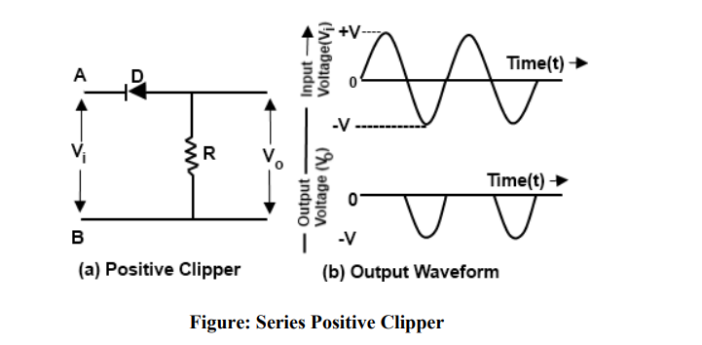

**APPARATUS:**

**Diode 1**

**Resistor 1**

**Oscilloscope 1**

**Multimeter 1**

**Chord 1**

**Capacitor 1**

**DC power supply 1**

**Trainer board 1**

**(4) Simulation circuits and Results:**

**Circuit1:**

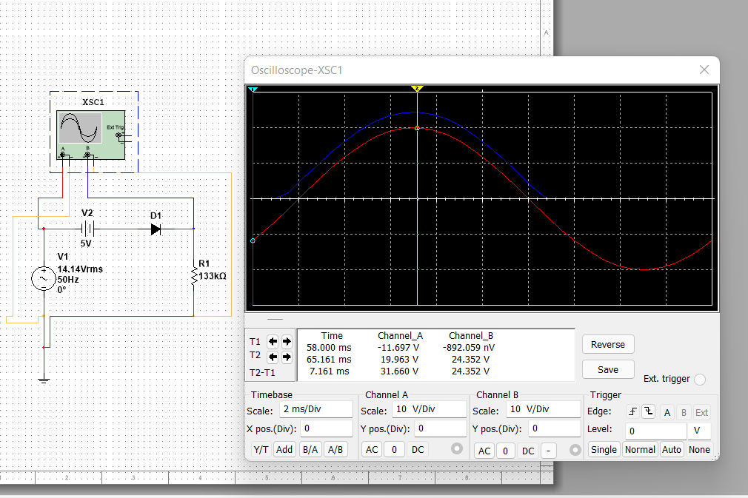

**Circuit2:**

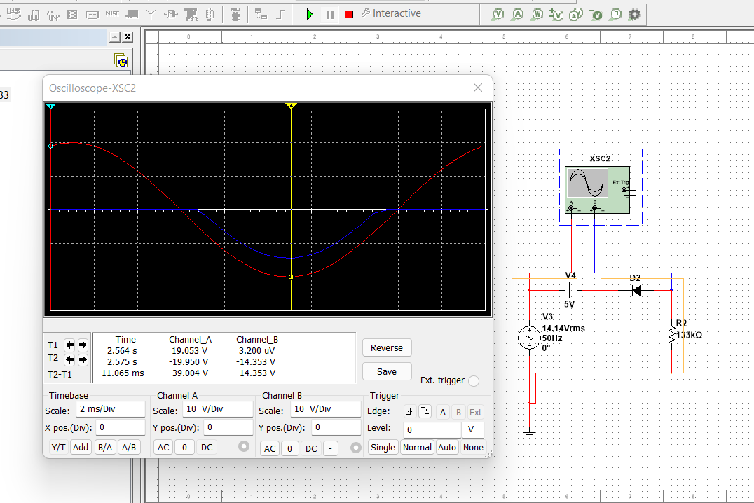

**Circuit3:**

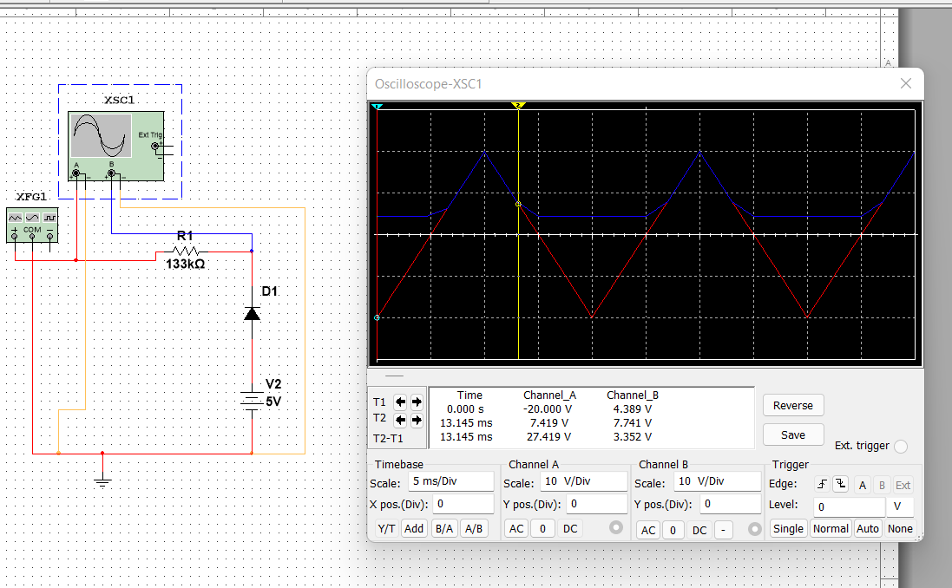

**Circuit4:**

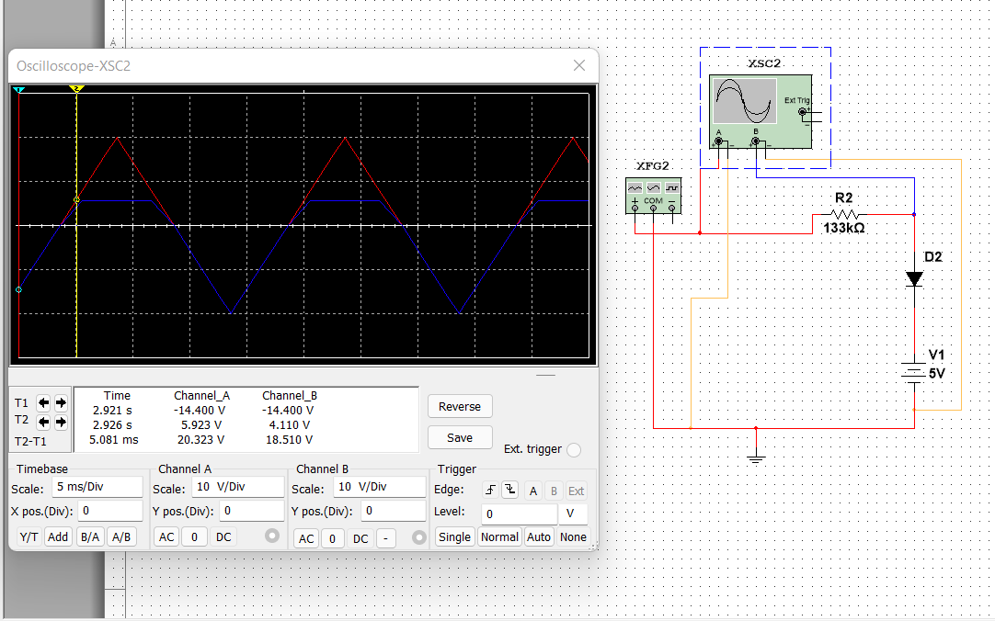

**Circuit5:**

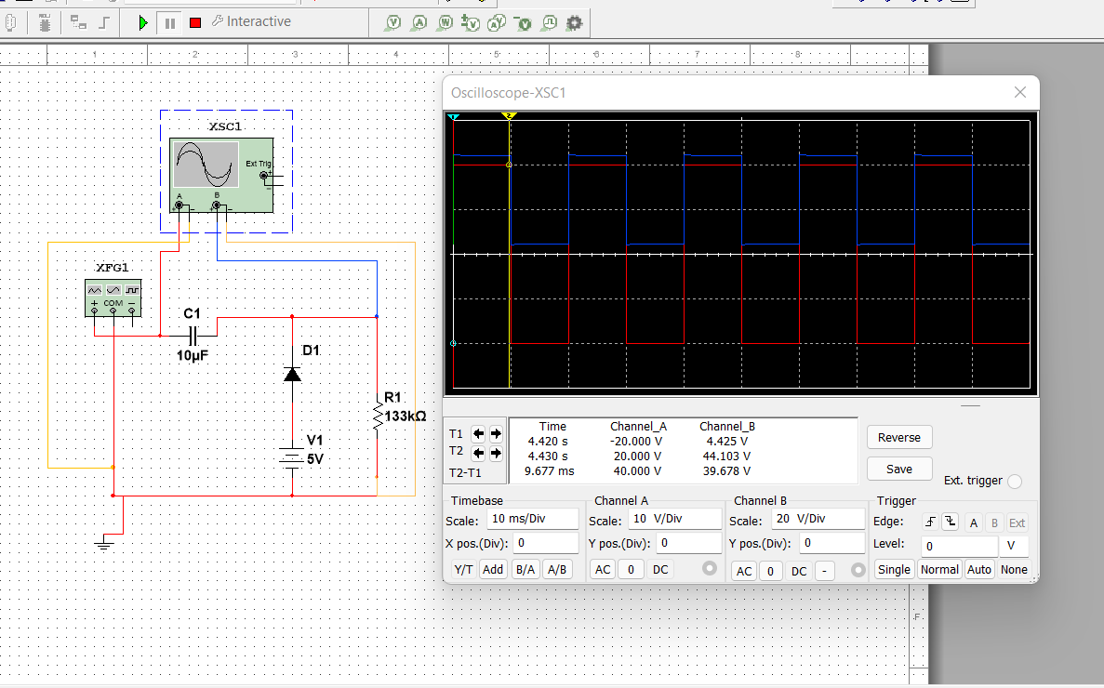

**Circuit6:**

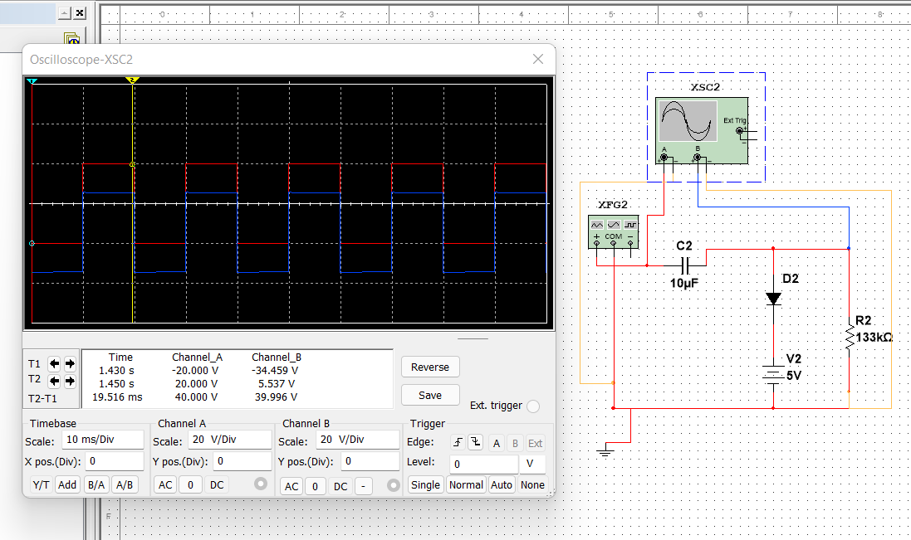

**(5) Difference between clipper and clamper circuit:**

i)A Clipper clips or removes a portion of the AC waveform while the clamper shifts the DC level.

ii)A clipper requires a diode and resistor while a clamper requires a diode, resistor & capacitor.

iii)A clipper is used for limiting the voltage of the AC signal while the Clamper is used for multiplying the voltage of an AC signal.

iv)A clipper changes the shape of the signal while the clamper does not affect the shape of the waveform.

v)A clipper cannot change the DC level of the signal while the Clamper’s main purpose is to change the DC level.

vi)A clipper does not require an energy-storing component while a clamper requires a capacitor for voltage amplification.

Clipper circuit operation:

In electronics, a clipper is a circuit designed to prevent a signal from exceeding a predetermined reference voltage level. ... A clipper circuit can remove certain portions of an arbitrary waveform near the positive or negative peaks or both. Clipping changes, the shape of the waveform and alters its spectral components.

Clamper circuit operation:

The clamper circuit moves the whole signal up or down to set either the positive peak or negative peak of the signal at the desired level.

**(6) Discussion:**

This experiment, we became familiar with clipping and clamping circuits. Clipping and

clamping are very widely used diode applications. Clipper circuits clip off signal voltages above

or below certain limits whereas clamper circuits are used to add dc voltage level to a signal. In

this experiment, we have constructed some clipper and clamping circuits, gave some input

voltage and seen the output of the waveform in the oscilloscope.

During the experiment, we have assumed to use some ideal diodes. But as in practical level,

every diode has some internal resistance and some diode voltage. So the waveform may vary.

During experiment procedure, we had built the circuits according to the circuit diagram. We

had to make sure not to remove or insert a diode into a circuit with voltage apply as it may

damage the diode. We also had to make sure that a replacement diode in the circuit is in the

right direction.

**(7) References:**

1) Adel S. Sedra, Kennth C. Smith, Microelectronic Circuits, Saunders College

Publishing, 3rd ed., ISBN: 0-03-051648-X, 1991.

2) David J. Comer, Donald T. Comer, Fundamentals of Electronic Circuit Design, John

Wiley & Sons Canada, Ltd.; ISBN: 0471410160, 2002.